PATIENT APPOINTMENT BOOKING WEBSITE
Appointment Booking
Figure 1. Patient Details and Contact Information
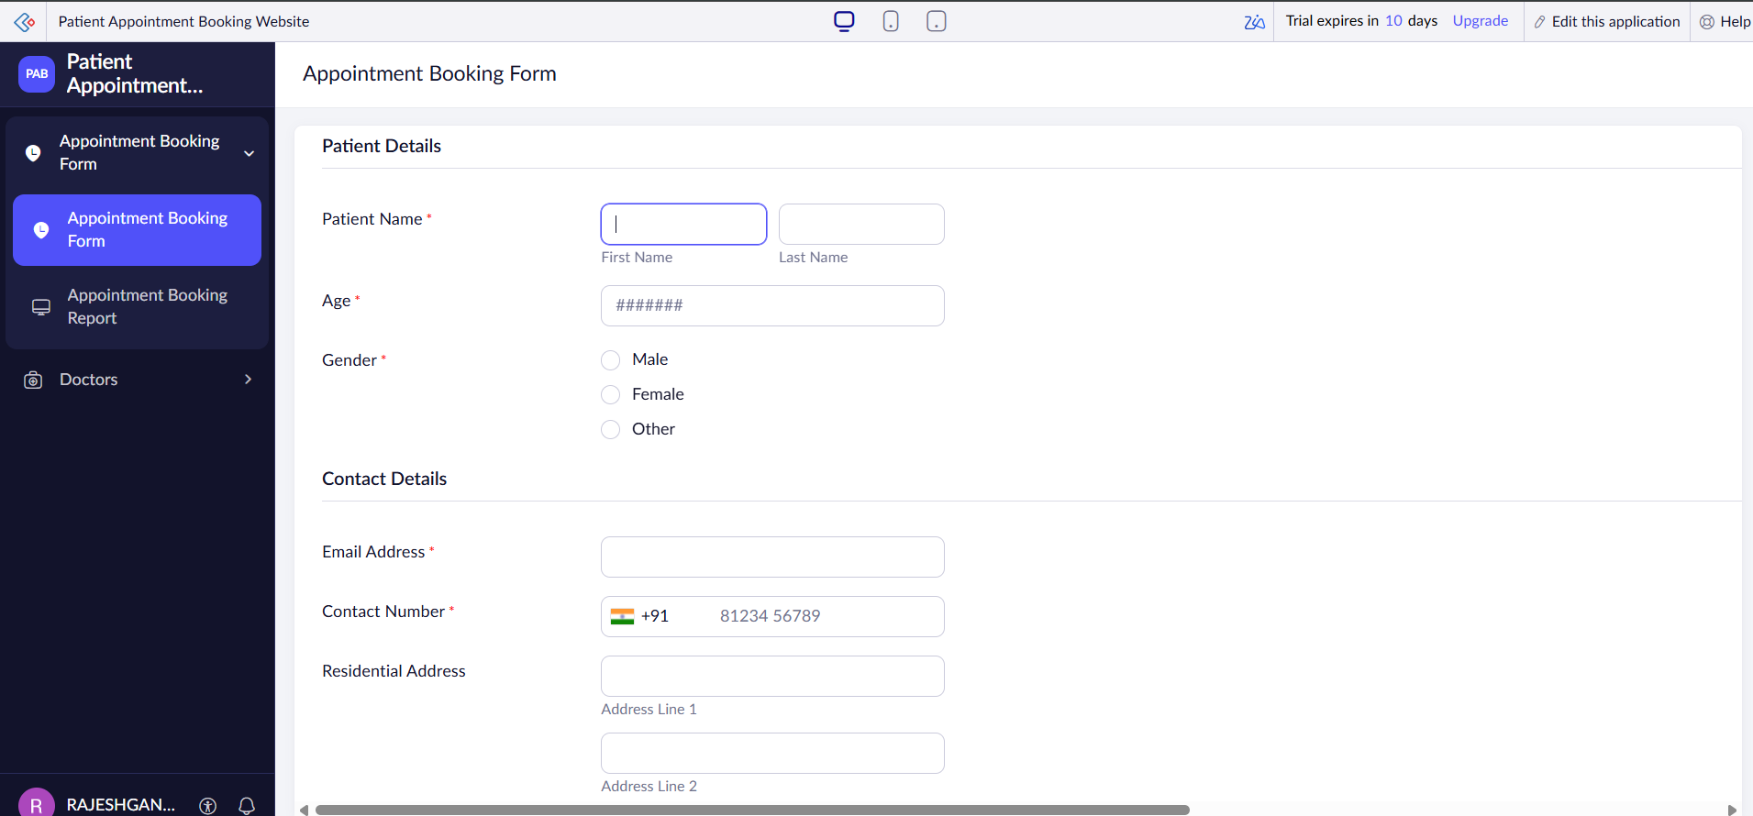

Appointment Booking
Figure 2. Medical Details and Appointment Scheduling
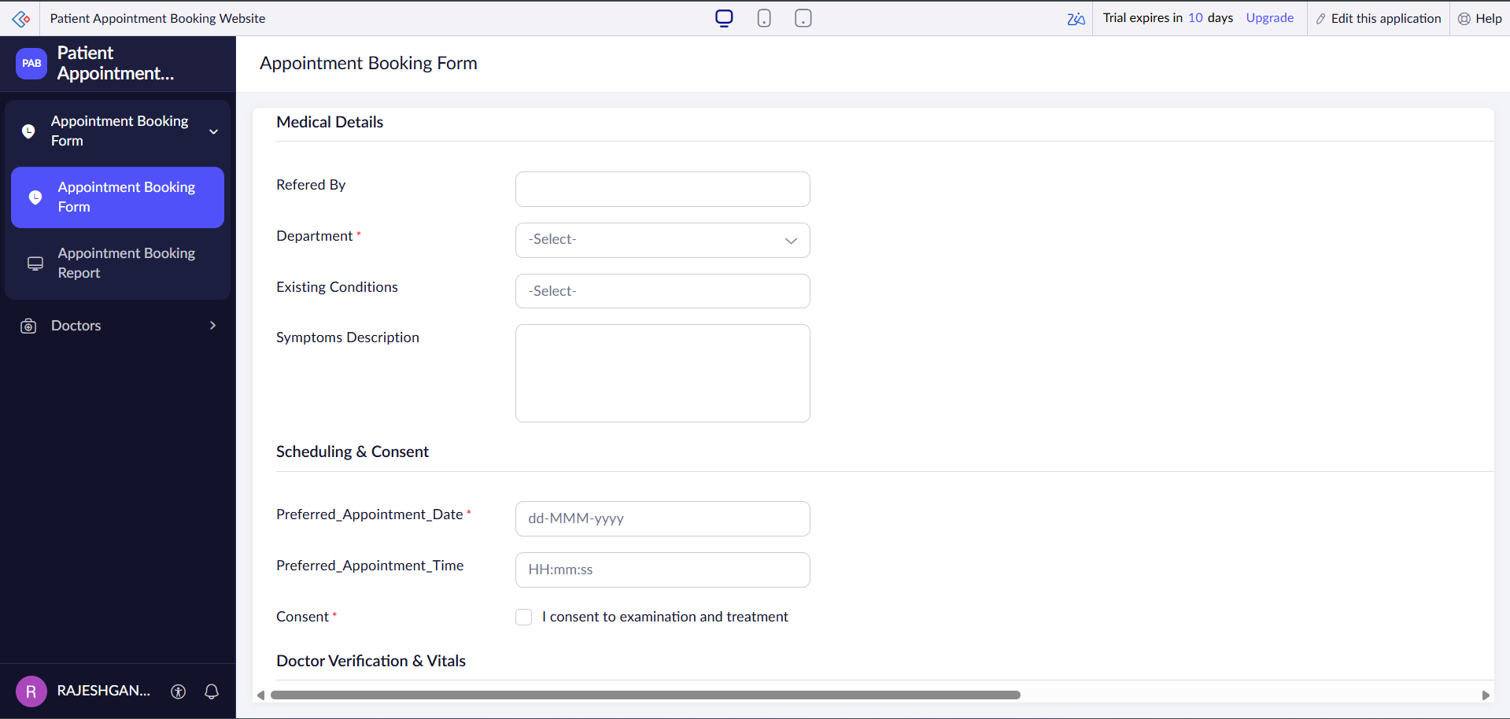

Appointment Booking
Figure 3. Doctor Verification and Medical Uploads
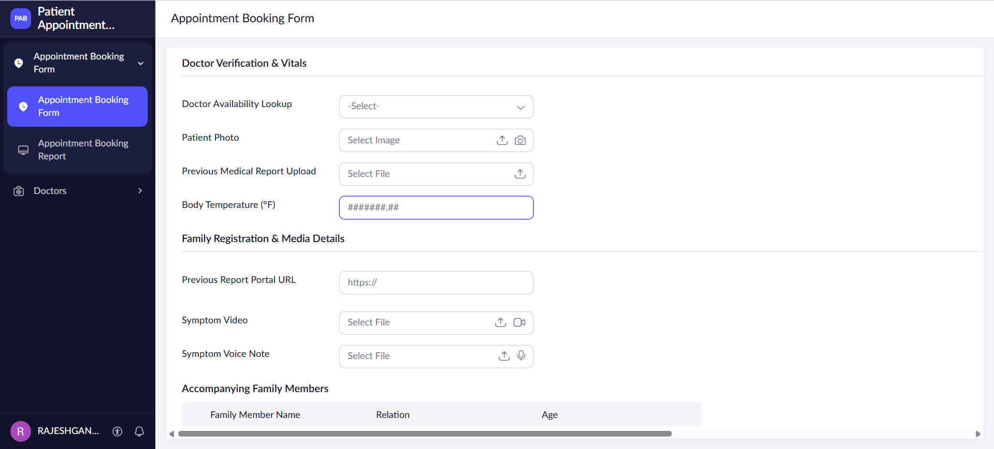

Appointment Booking
Figure 4. Family Members, Fees and Insurance
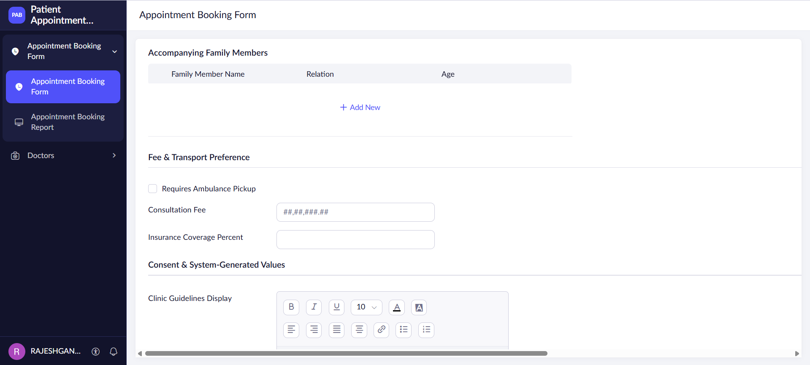

Appointment Booking
Figure 5. Clinic Guidelines, Digital Signature and Submission
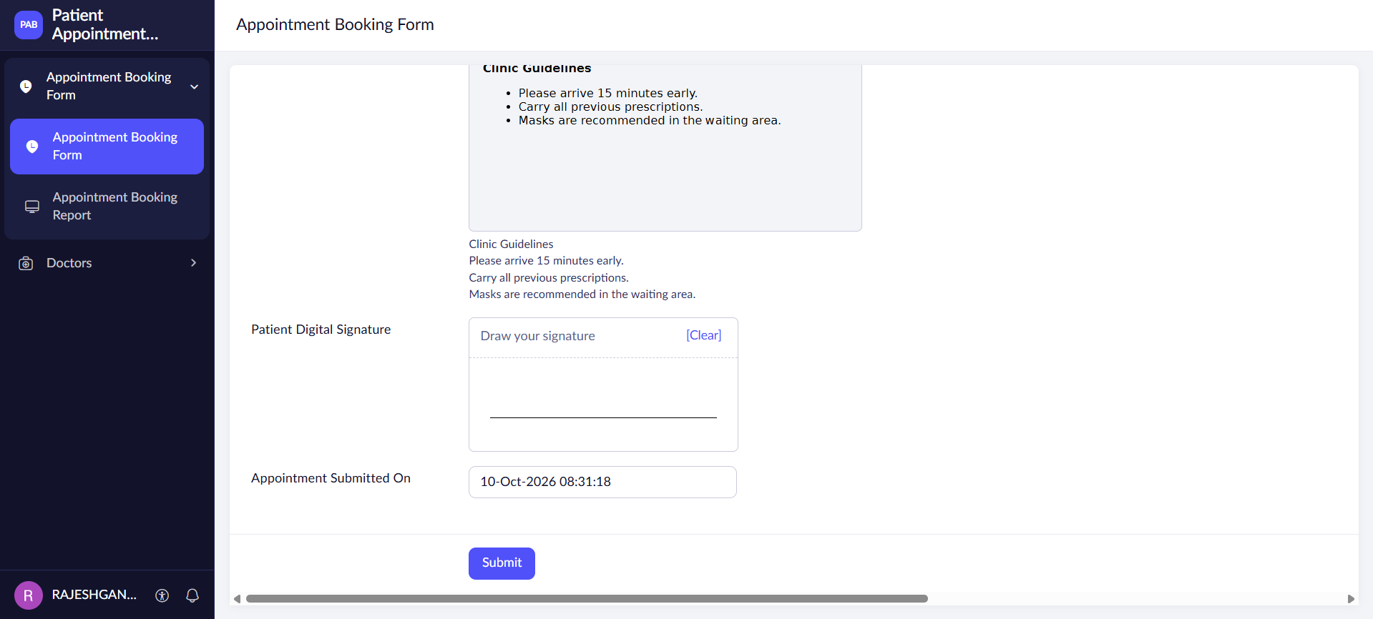

Appointment Booking
Figure 6. Appointment Booking Report – Patient Records
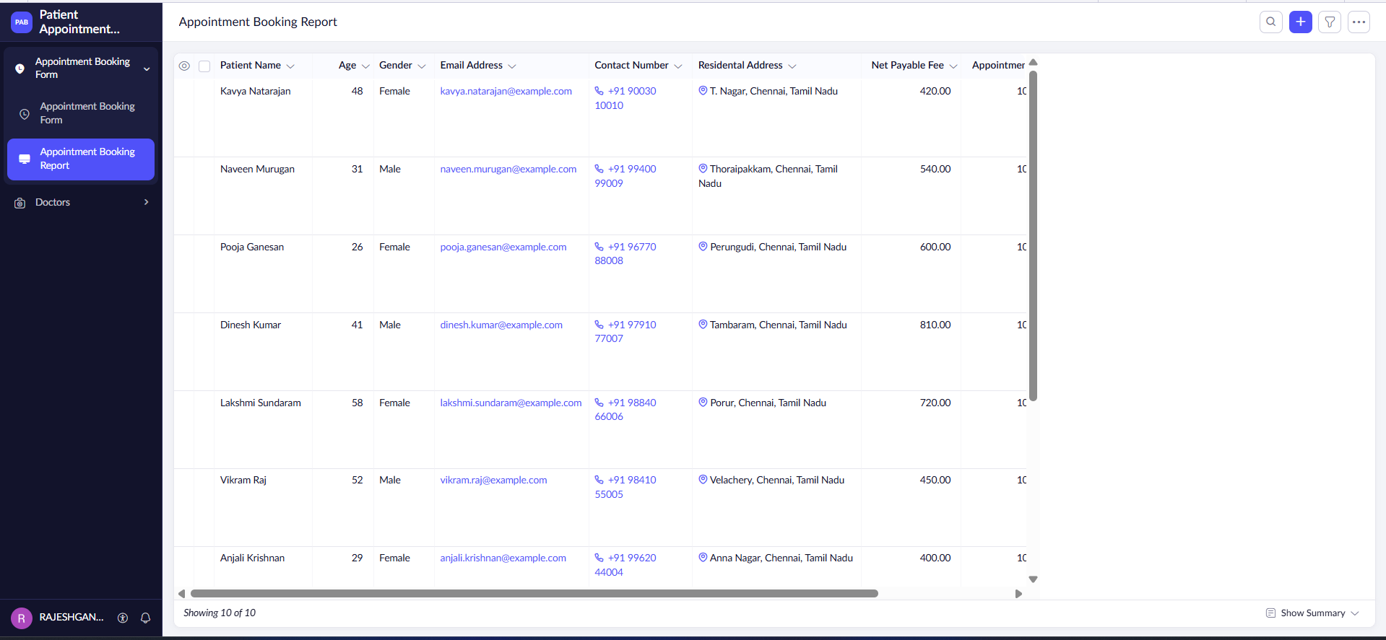

Appointment Booking
Figure 7. Appointment Booking Report – IDs and QR Codes
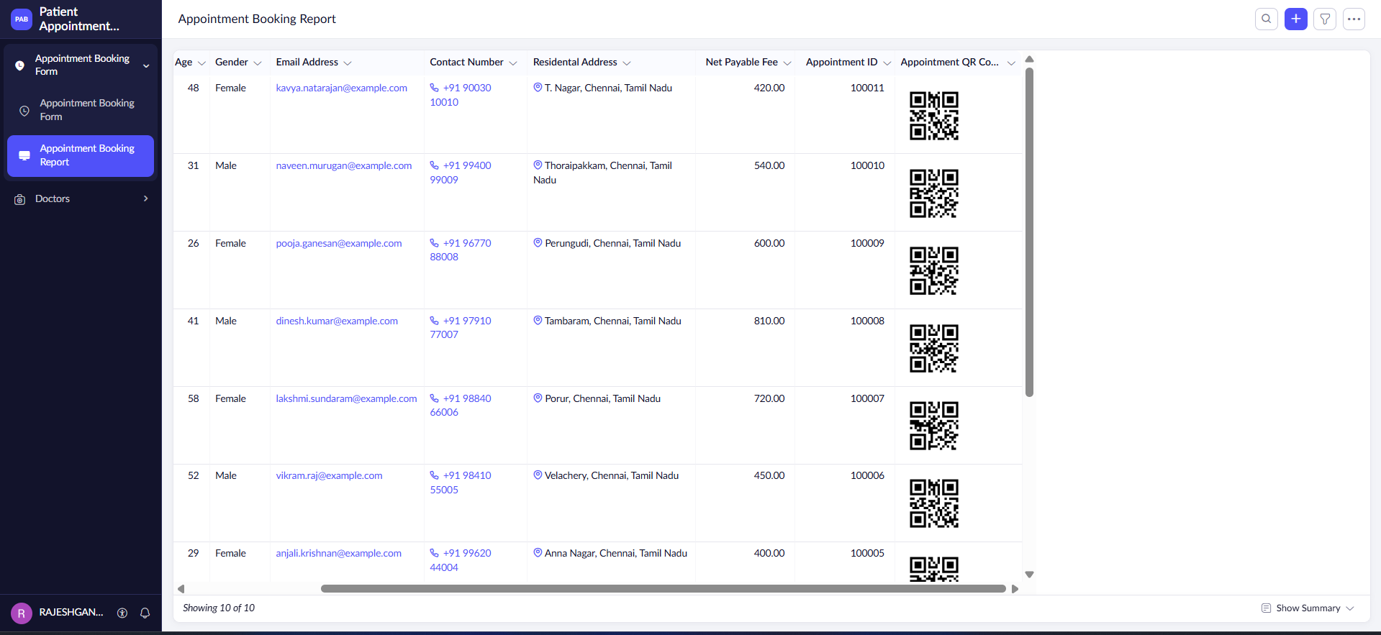

Doctors
Figure 8. Doctor Registration Form
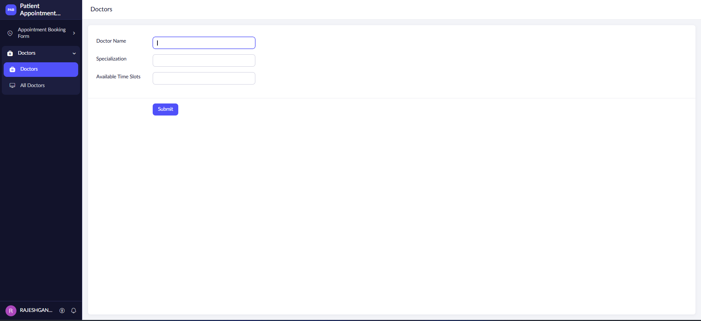

Doctors
Figure 9. All Doctors and Available Time Slots
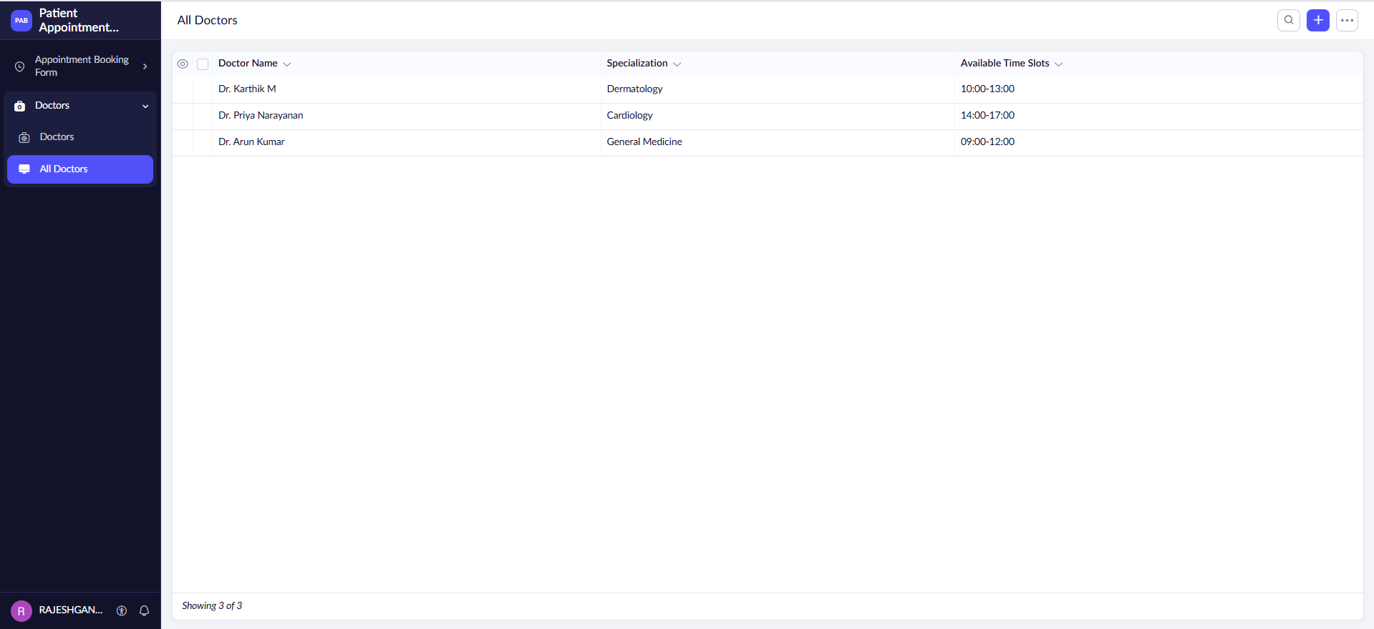

Workflow
Figure 10. Appointment Booking – Automated Workflows
